**SQL QUESTIONS**

# 1. Retrieve all successful bookings:

select * from bookings

where booking_status = 'Success';

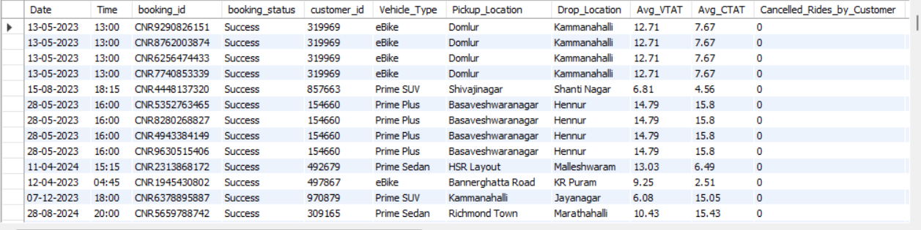

# 2. Find the average ride distance for each vehicle type:

select vehicle_type , avg(Ride_distance) as avg_distance

from bookings

group by vehicle_type;

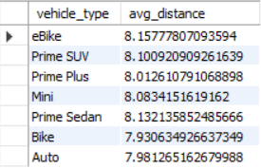

# 3. Get the total number of cancelled rides by customers:

select count(*)

from bookings

where booking_status = 'Cancelled by Customer';



# 4. List the top 5 customers who booked the highest number of rides:

select customer_id, count(booking_id) as total_rides from bookings

where booking_status='Success'

group by customer_id

order by total_rides desc

limit 5;

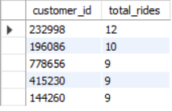

# 5. Get the number of rides cancelled by drivers due to personal and car-related issues:

select count(Reason_for_cancelling_by_Driver) as reason from bookings

where Reason_for_cancelling_by_Driver = 'Personal & Car related issues' ;



# 6. Find the maximum and minimum driver ratings for Prime Sedan bookings:

select vehicle_type,max(driver_ratings) as max_rating ,min(driver_ratings) as min_rating

from bookings

where vehicle_type = 'Prime Sedan';



# 7. Retrieve total payment by vechicle type :

select vehicle_type, round(sum(booking_value),2) as total from bookings

group by vehicle_type;

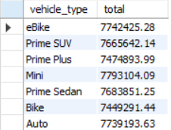

# 8. Find the average customer rating per vehicle type:

select vehicle_type, round(avg(customer_rating),2) as avg_rating from bookings

group by vehicle_type;

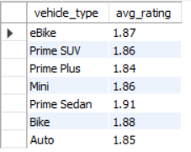

# 9. Calculate the total booking value of rides completed successfully:

select sum(booking_value) as total from bookings

where booking_status = 'Success';



# 10. List all incomplete rides along with the reason:

select booking_id,Incomplete_Rides_Reason

from bookings

where incomplete_rides = '1';

